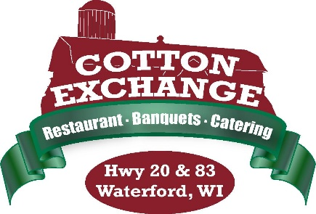
~Gift Certificate Notification~

To our valued customers,
We are notifying you regarding our old, new and expired gift certificates that you may have purchased or received as a gift.

Please see below the types of gift cards and information listed below:
Need to Exchange for New Card Valid No Changes Valid No changes
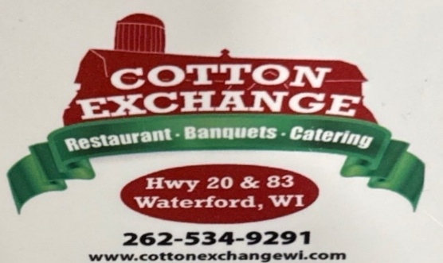
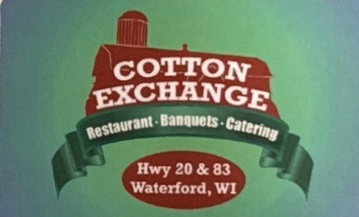
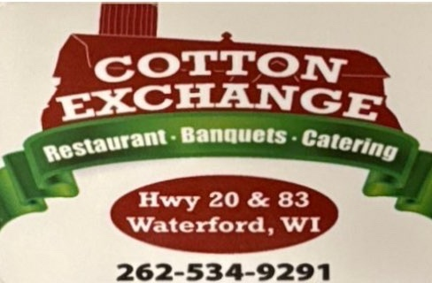

16 Digit Code
16 Digit Code with No Spacing 16 Digit Code with Spacing Not Valid, Expired Card (below)

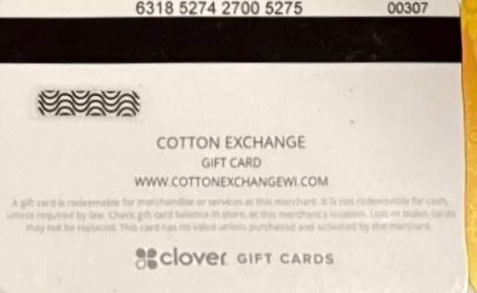
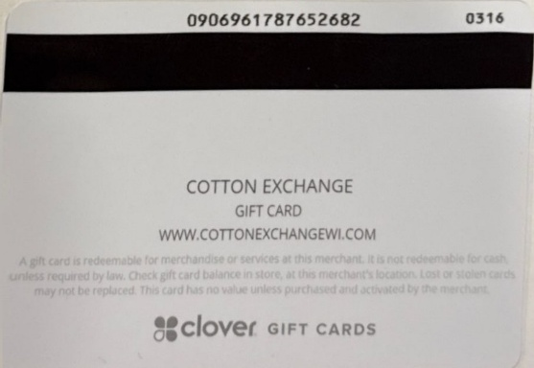

At your convenience, please stop by or contact us to assist you with your new gift card. If you’re unable to stop by, please phone or email us and we will have you mail us the old gift card, and we’ll re-issue your new gift card and send it to you.
We request that you convert your old gift card into our new gift card by December 31, 2025. After this date we will not be honoring the old gift cards from our previous system.

We apologize for the inconvenience and appreciate your patience as we convert our old gift cards into new gift cards
within our new system. Thank you for being our loyal customer, we appreciate you!

345 Hickory Hollow, Waterford, WI 53185 Phone: 262-534-9291 Email: cottonexchangewi@gmail.com

